**UNIX Overview**

*Unix is a multitasking, multiuser operating system and is mostly command prompt/ console driven.*

**What is File Structure?**

**Windows Path:**

E:\Tutorials\Java\Java.ppt

**Unix Path:**

* Unix Operating systems have only one Drive and it called as Root Drive

Root Drive:

/home/ec2-user/one/two/java.ppt

/bin

/sbin

/ext

/temp

**Absolute Path:**

Complete Path starting from the Drive Location

**Relative Path:**

Short Path with reference to Current Position

**Drive:**

Every Drive has Folders/Directories and Files

Directory = Parent, Child, Siblings

**Different Commands:**

**E:\Tutorials\Java**

**.. =** Navigate to Parent Directory

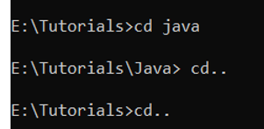

**..\=** Navigate to Parent of Parent Directory

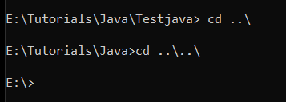

Absolute Path:

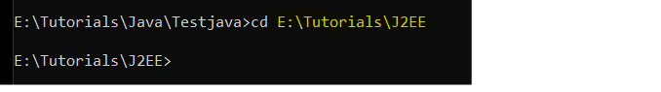

Relative Path:

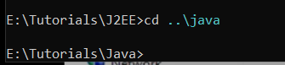

Create Drive:

mkdir = Command is used to create Directory/Folder

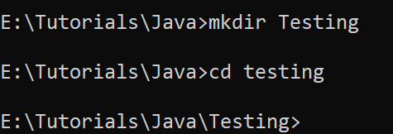

Remove Directory:

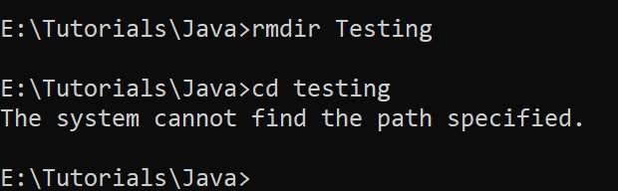

**UNIX Commands:**

1. **Pwd:** Present Working Directory**.** Will show the current working Directory
2. **ls :** This Command Lists all files under a folder
3. **ls –lrt :** This command lists the files under a folder along with other file details such as owner, access details, size, modified date etc
4. **chmod:** File – the command has 3 digits that assign access permission in the order owner, group, and others. Read – 4 . Write – 2, Execute – 1

File System:

**Read, Write and Execute Permission**

Example:

**Developer Team:**

Jhon = (ALL) Program to Facebook Software

Jane = Read & Execute

Mike = Ream & Execute

**Testing Team:**

Andy = Only Execute Permission

Ron = Only Execute Permission

**Public Team:**

XYZ == Only Execute Permission

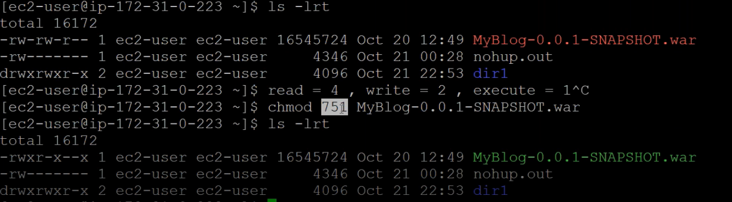

1. **cp <src_path> <dest_path>:** Copies file from one location to another

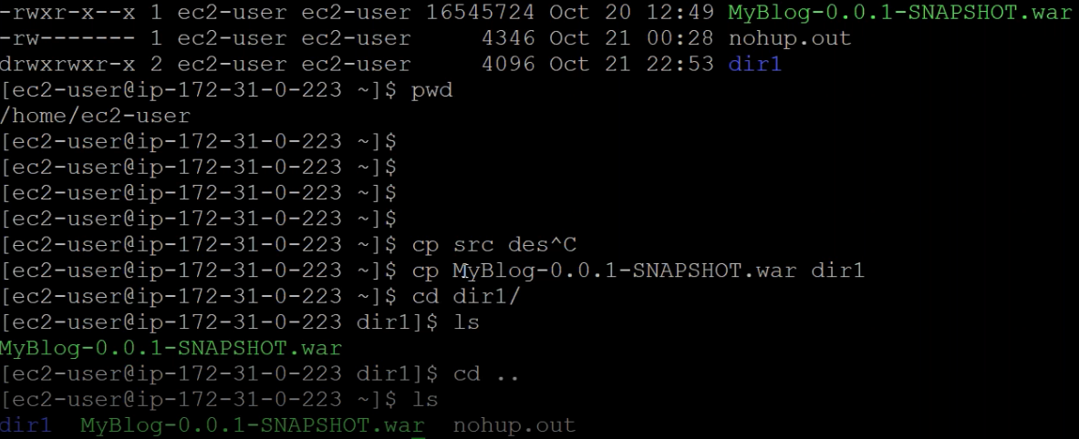

**Absolute Path:**



1. **mv <src_path> <dest_path>:** Cut Paste or move a file

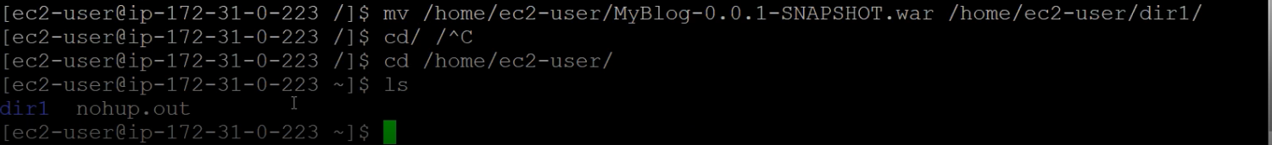

1. **grep**: search string in a text file. grep “java” 1.txt

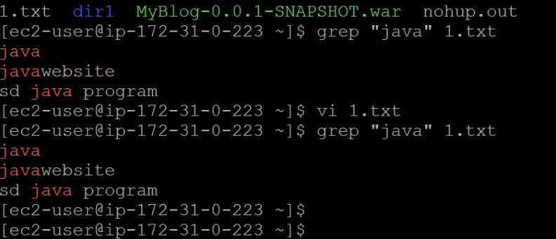

1. **cp -r <src_path> <dest_path>:** Copying Entire Directory/Folder into another Directory/Folder



1. **Ps –aef : Task manager command: Command lists all the files with their PID etc**

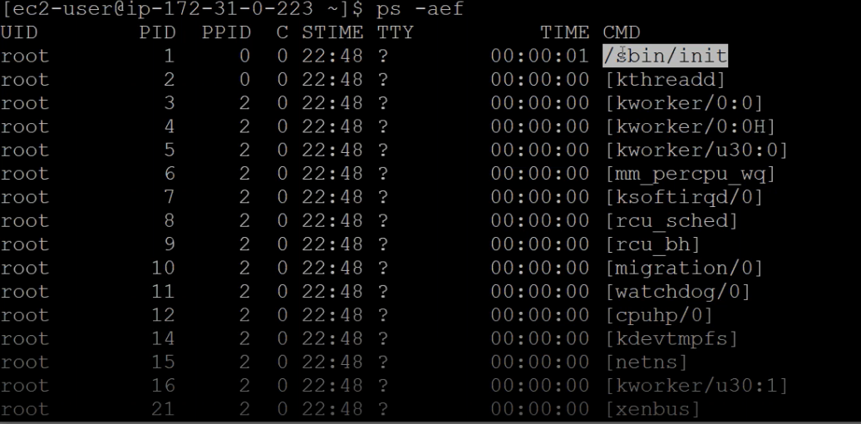

1. **kill:** kill command with option 9 terminates the process, option 3 takes thread dump.

